Zebra Print Engine Automatic Disconnection
The Zebra Print Engine has a feature to automatically disconnect a TCP/IP connection after 5 minutes. To disable this feature use a web browser to connect to the printer’s ip address.
Click View and Modify Printer Settings. If you get a login screen, Zebra’s default password is 1234.
Click Network Configuration.
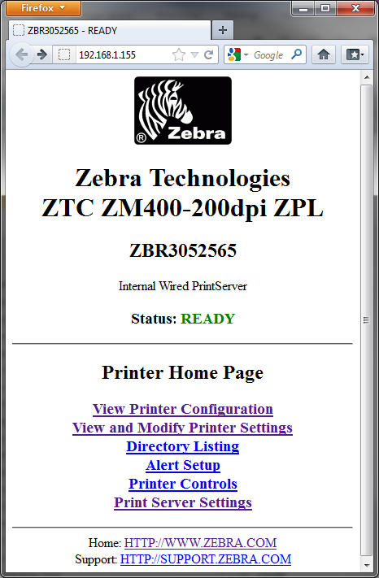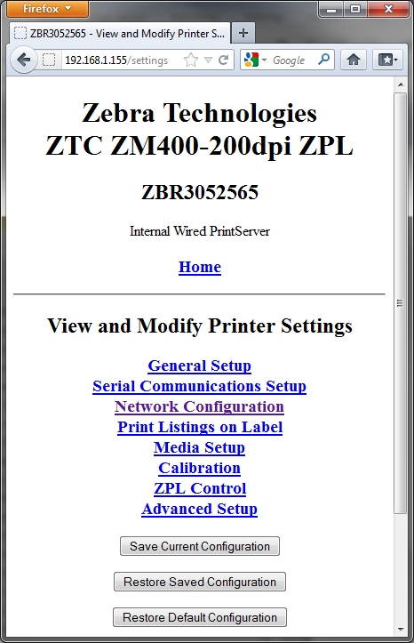
Click TCP/IP Settings. Set Timeout Checking to NO. Click Submit Changes.
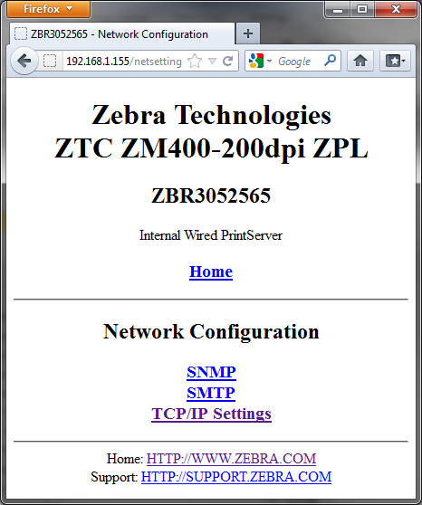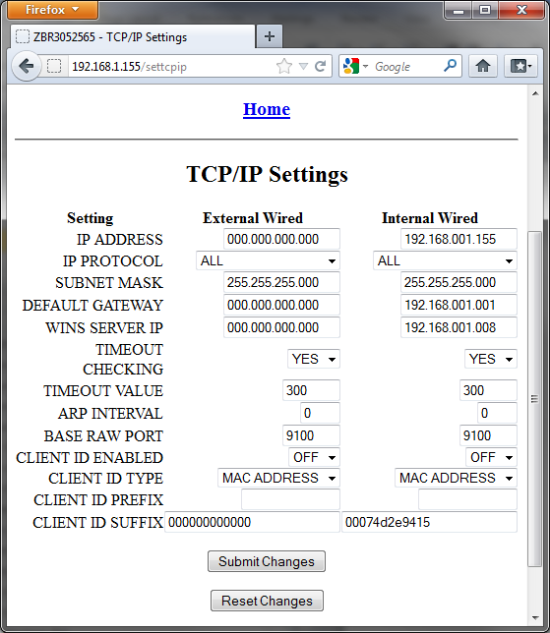

Click “Save Current Configuration” from the “View and Modify Printer Settings” page to make the change permanent!

